**Project Development Phase**

**Model Performance Test**

|  |  |
| --- | --- |
| Date | 18 November 2022 |
| Team ID | PNT2022TMID36181 |
| Project Name | Project – Early detection of chronic kidney disease using machine learning |
| Maximum Marks | 10 Marks |

**Model Performance Testing:**

Project team shall fill the following information in model performance testing template.

|  |  |  |  |
| --- | --- | --- | --- |
| **S.No.** | **Parameter** | **Values** | **Screenshot** |
|  | Model Summary | **-** | Attached Below |
|  | Accuracy | Training Accuracy -   Validation Accuracy - | Attached Below |

**MODEL SUMMARY**

**OUTPUT 1**

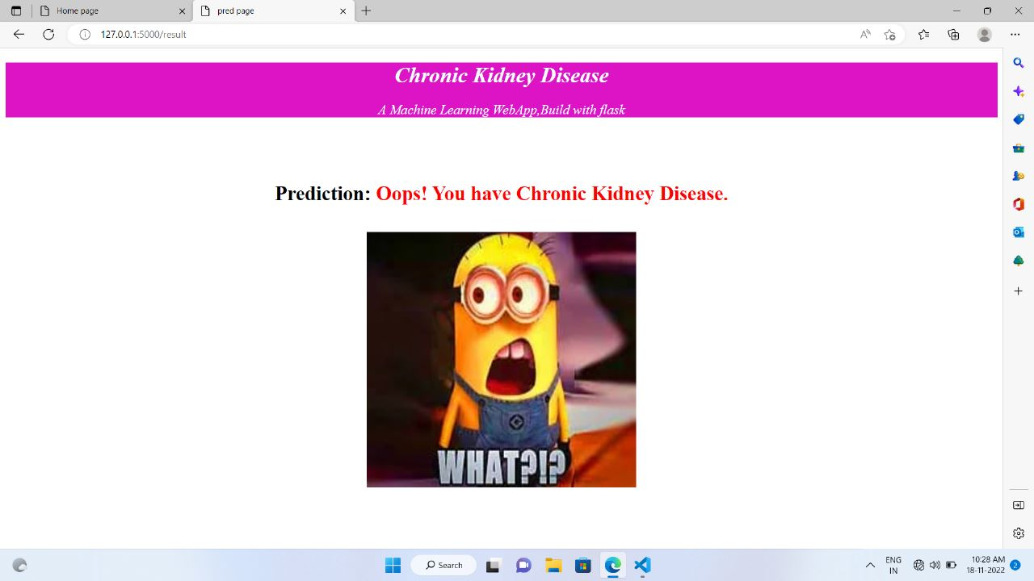

**OUTPUT 2**

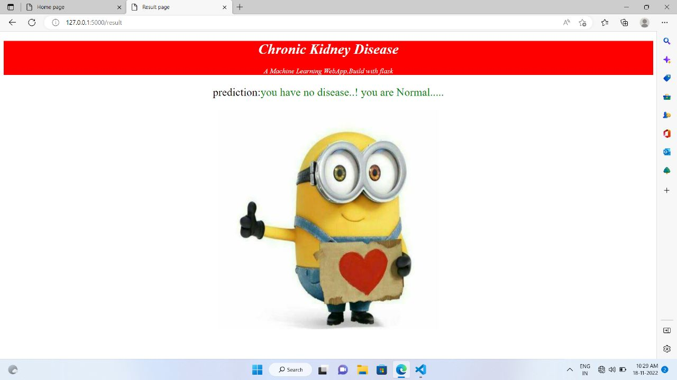**ACCURACY**



